Full color Asynchronous controller Parameter
----------HD-C10

Led display controller functions
HD-C10 is Asynchronous led display controller, and working no need PC. Play high definition programs .like video, image, animation, text, temperature, office file etc. The system include two parts: HD-C10 controller and software called HD Player.
Usually it is one screen with one card, but if the screen is bigger, for best result, you can add R500/R501 cascade connection.

2. Device list
types | model | Main function
Full color asynchronous cascade controller | HD-C10 | Asynchronous core controller, with memory function,it can connect screen
Receiving card | R500/R501 | Connect screen, show the program on LED screen
Controller software | HD Player | Screen parameter setting, edit program,sending program
Accessories |  | HUB board, cable , U-disk

3, Applycation scenarios

control card can connected with router, internet cascaded management sketch as bellow:
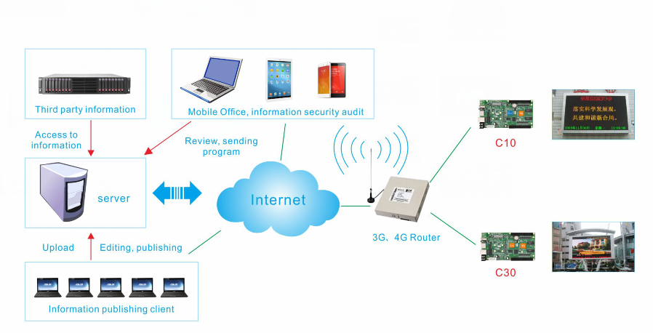

Picture 1-1 managing several screen through Internet

2) control card can connect with computer, sketch as bellow:
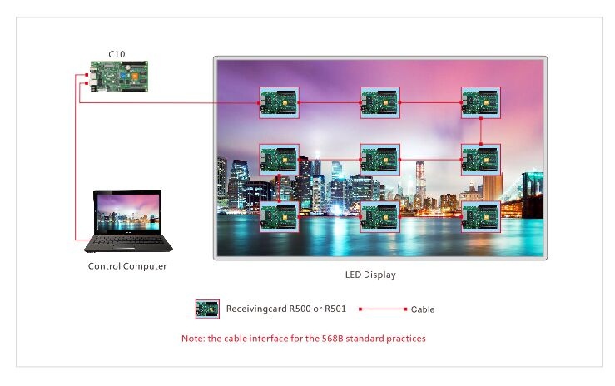 Picture 1-2 just one screen - control by cable directly

Notice : each screen just need one C10 card, the number of receiving card depend on screen size.

- Update the program besides you can use cable connect C10, U-disk and moving hard disk drive.

4, Scheme features

1) compatible indoor and outdoor, full color and single/dual color module

2) support video play,picture and text effect

3) support 0-65536 gray level

4) support U-disk expand memory infinitely,playing when inserting

5) Standard dual channel stereo output

6) No need IP setting, automatic identification

7) Internet cascaded management, internet, 3G remote control

5. System function list

Module types | compatible indoor and outdoor, full color and single/dual color module; support virtual module; Support PWM chips such as MBI5041/5042、MBI5050、MY9221、MY9268.
Scanning mode | Support static state scan to 1/32 scan way
Control range | 384（width）*320（height）；1024（width）*120（height）；240（width）*512（height）;
single receiving card pixels control range | Recommend: R500: 256（width）*128（height）  R501: 256（width）*192（height）
Gray level | Support 0-65536 adjustable
Program update | Direct connect computer,LAN, Internet, U-disk,mobile hard disk drive
basic function | Support the basic function such as video, pictures, animated Gif, text, office document, clock, timer  Support extend the functionality such as remote control, temperature, humidity, brightness
Video function | support hardware video decoder, sending directly, without transcoding waiting.  Support common patterns AVI、WMV、RMVB、MP4、3GP、ASF、MPG、FLV、F4V、MKV、MOV、DAT、VOB、TRP、TS、WEBM
Picture format | Support BMP、GIF、JPG、JPEG、PNG、PBM、PGM、PPM、XPM、XBM and so on.
Text | Support for text editing, picture insertion and support word、txt、rtf、html direct importing.
Document | Support Office2007 such as DOC、DOCX、XLSX、XLS、PPT、PPTX document format.
clock | Support analog clock, digital clock, A variety of dial clock
audio output | Standard dual channel stereo output
memory capacity | On board Flash 4GB  Allows users to use U-disk memory expansion
Communication type | Million Ethernet interfaces, Internet, WLAN networking.
operating temperature | -20℃-80℃
HD-C10 access port | IN: 5V power supply terminal X1, 10/100M RJ45 x1，USB 2.0 x1，The screen test button X1  OUT:1000M RJ45 x1，dual stereo:AUDIO x1 , 2 of 50 pin
working voltage | 4.5V~5.5V
software | LED Art

6.Model Selection Reference
Model | Control range(width* height) | sub model
HD-C10 | 384（width）*256（height）;  1024（width）*96（height）;  304（width）*320（height）; | HD-C10F（WIFI）  HD-C10W（3G）  HD-C10G（4G）
R500 | Recommend :256（width）*128（height）
R501 | Recommend :256（width）*192（height）

7,Port Instruction
- HD-C10 Port Instruction:

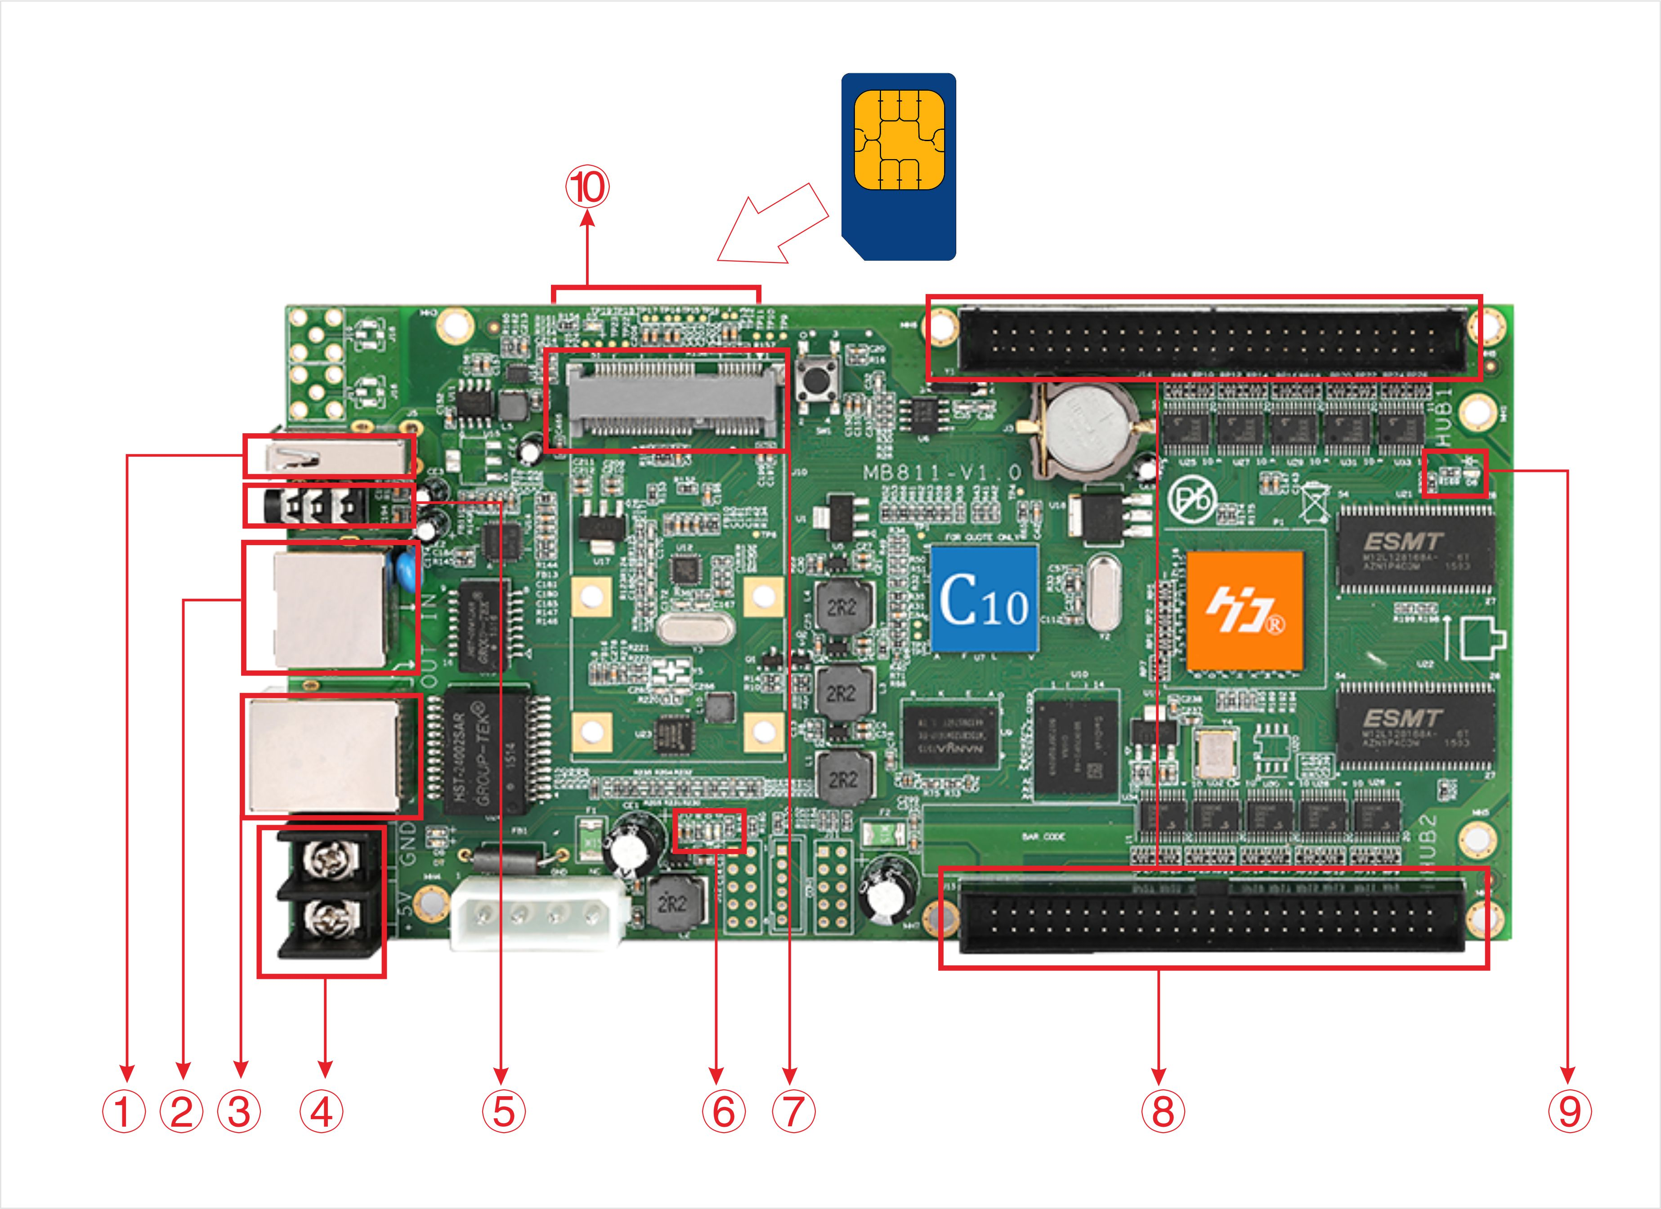
①USB port, connect USB device, such as: U-disk and mobile hard disk drive
②input network port, 100M network port, Normal working: orange lamp always on,green lamp flicker.
③output network port,1000M network port, Normal working: D7 green lamp always on, D8 green lamp flicker.
④ power interface, 2 pin power terminal connect with 5V power
⑤ Audio output interface, standard dual channel stereo output
⑥power led-D2 green lamp normal working is always on, running lights-D1green lamp normal working is flicker.
⑦ MINIPCIE connect 3G model or WIFI model (select-able)
⑧1 of 50 pin, connect HUB board, connecting with all kind of cabinet interface through HUB
⑨Display lamp-D7green lamp normal working is flicker
⑩The back SIM card slot, inserted with 3G/4G card for 3G/4G internet solutions
2) 50 pin definition
Support 16 “RGBR” Parallel Data, definition as below:

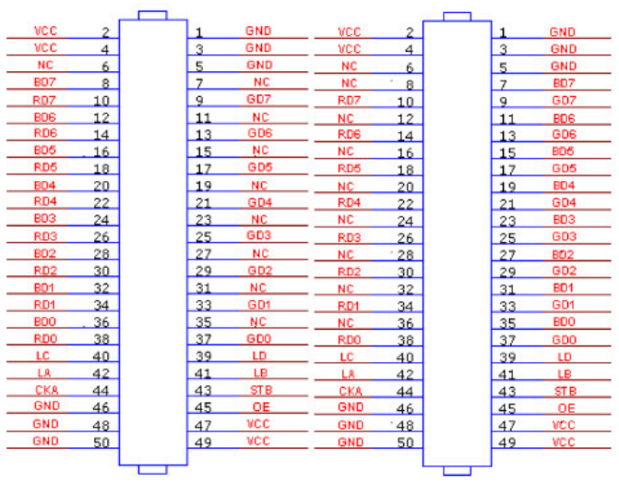
General Full Color Port 1 General Full Color Port 2
8, Dimension Chart
- HD-C10 dimension chart as bellow:
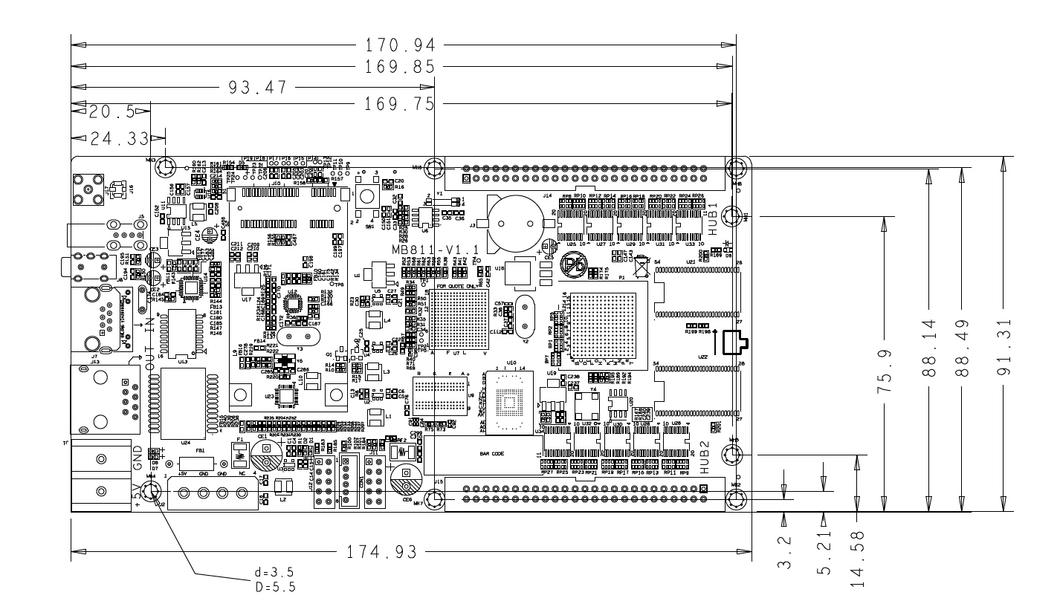 Picture 8-1 HD-C10 dimension chart

2) Receiving card dimension chart as below
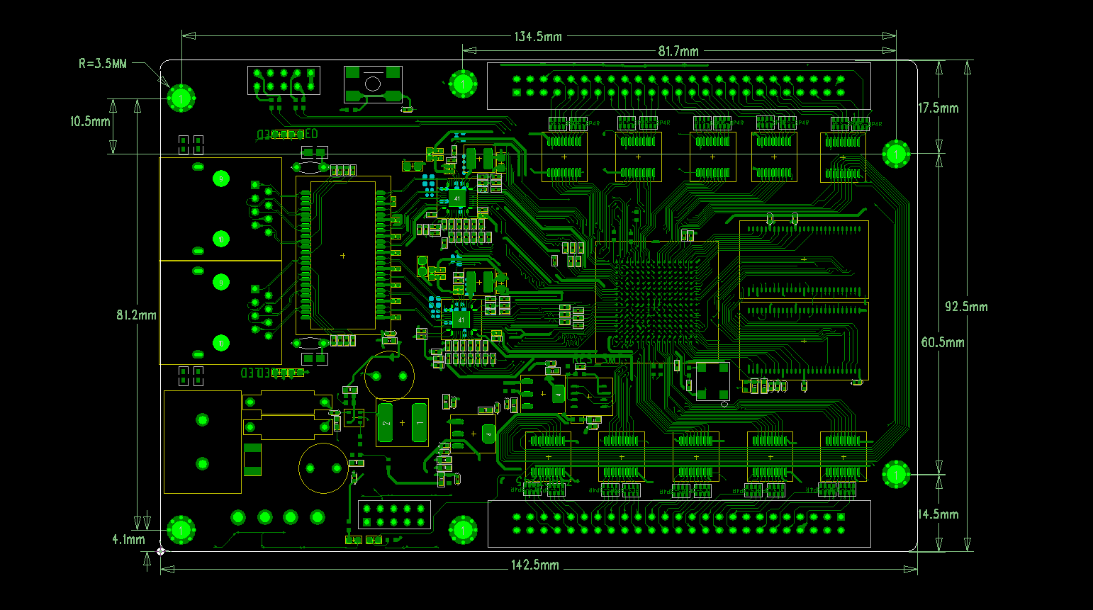
Picture 8-2 dimension chart R500

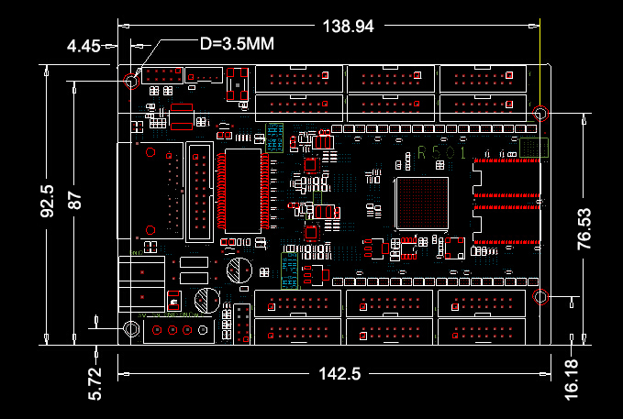
Picture 8-3 Dimension Chart R501

